Lab 8
In Lab Activity
Example 1:
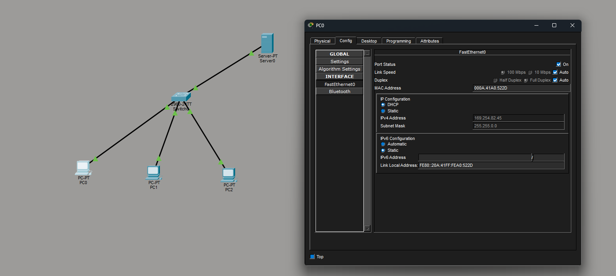

Example 2:
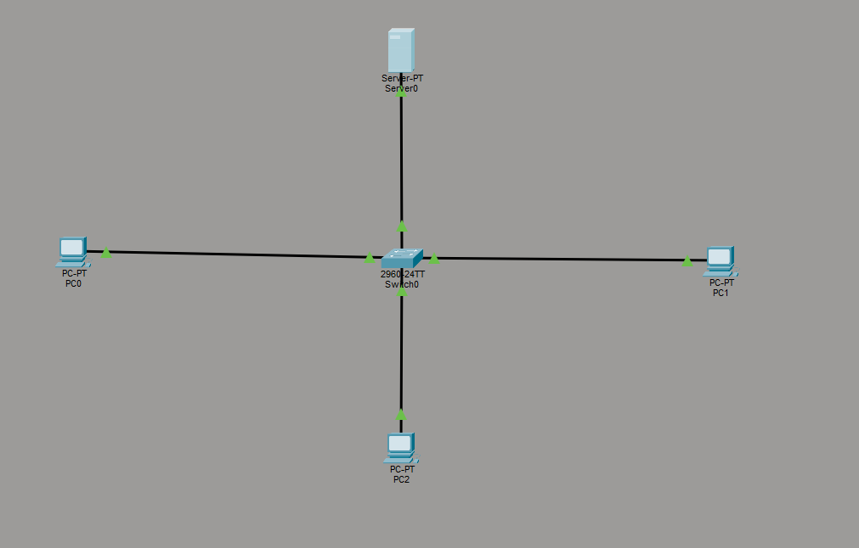

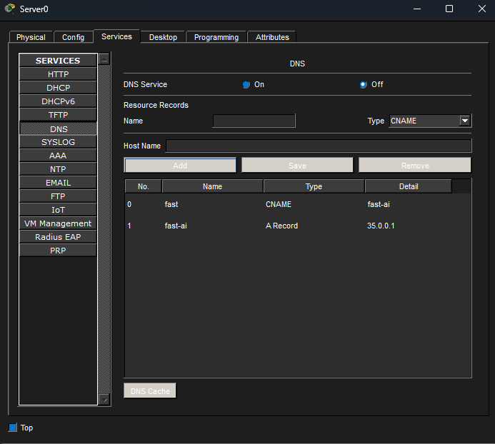

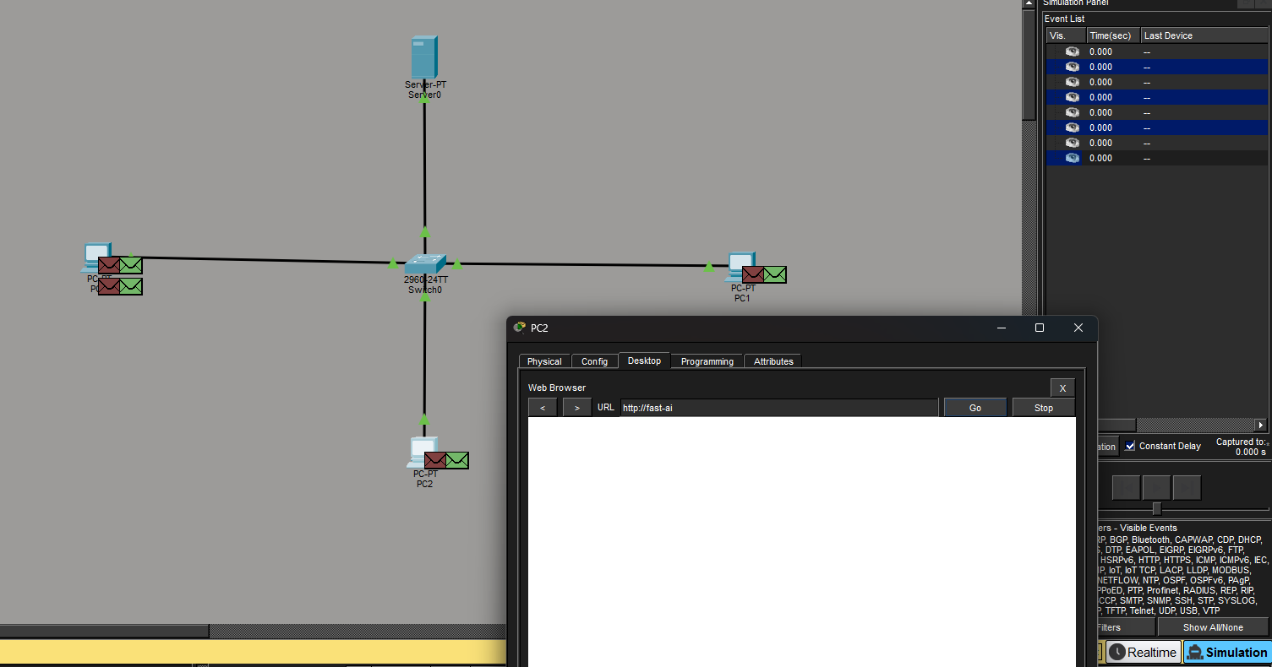

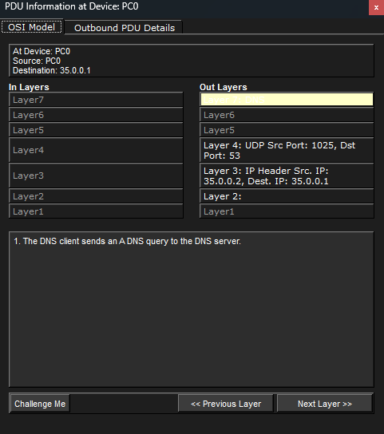
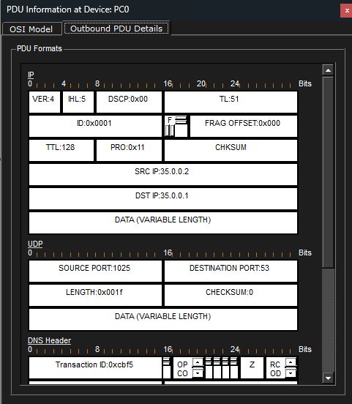

Example 3:
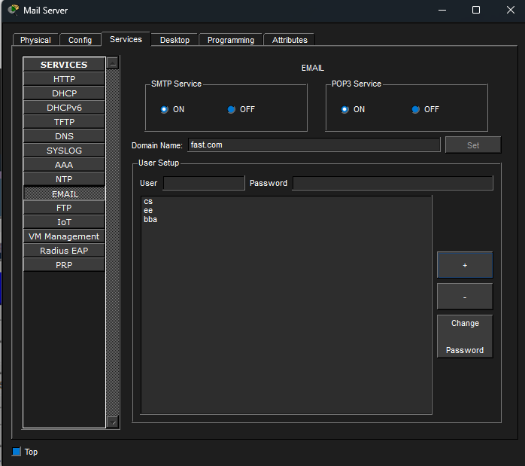
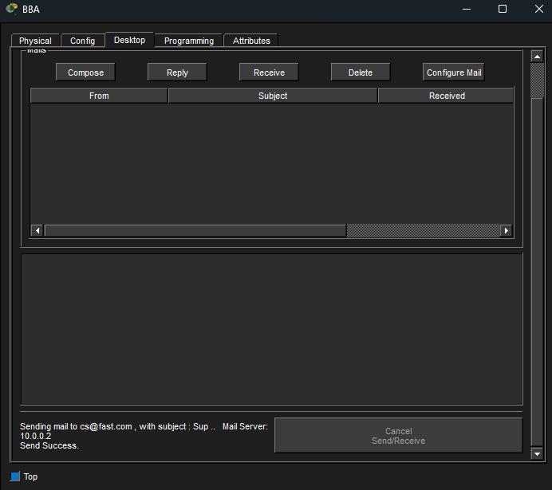
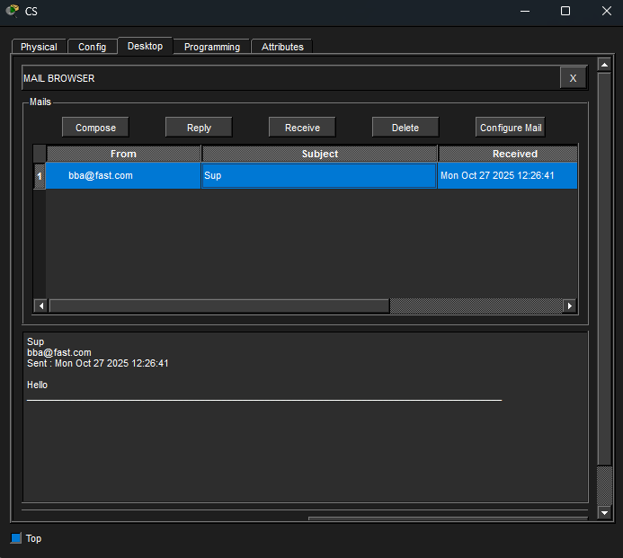

Home Submission:
Task 1:
Part (i)
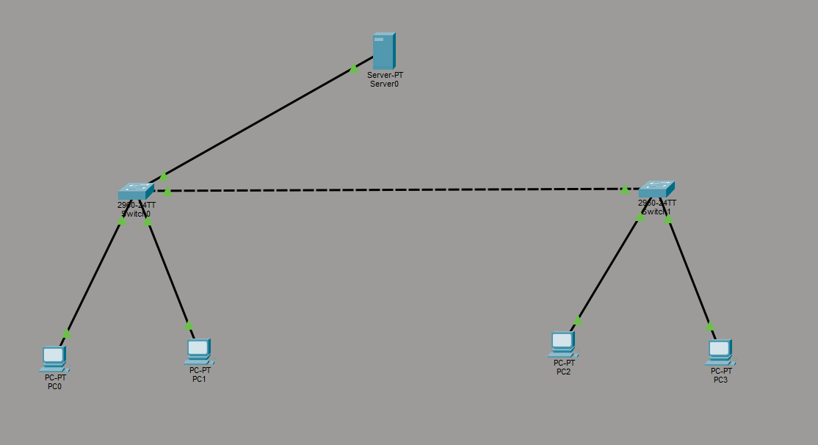
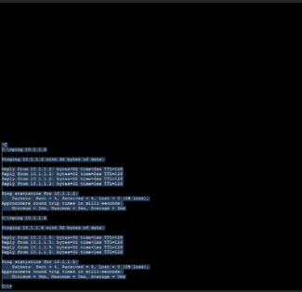

Devices Functionality:
PCs initiate data transfers, such as ping or HTTP requests, to other PCs or the server. To establish communication, a PC uses the Address Resolution Protocol (ARP) to find the specific MAC address that corresponds to the destination IP address.
The server communicates with PCs to deliver services and participates in ARP resolution just like any other host on the network.
The network infrastructure includes Switch1, which connects the server, PCs, and Switch2, forming one continuous broadcast domain. Switch2 expands the LAN by linking in more PCs. Both switches utilize MAC learning and forwarding mechanisms to ensure data packets are delivered efficiently.

ARP Format:
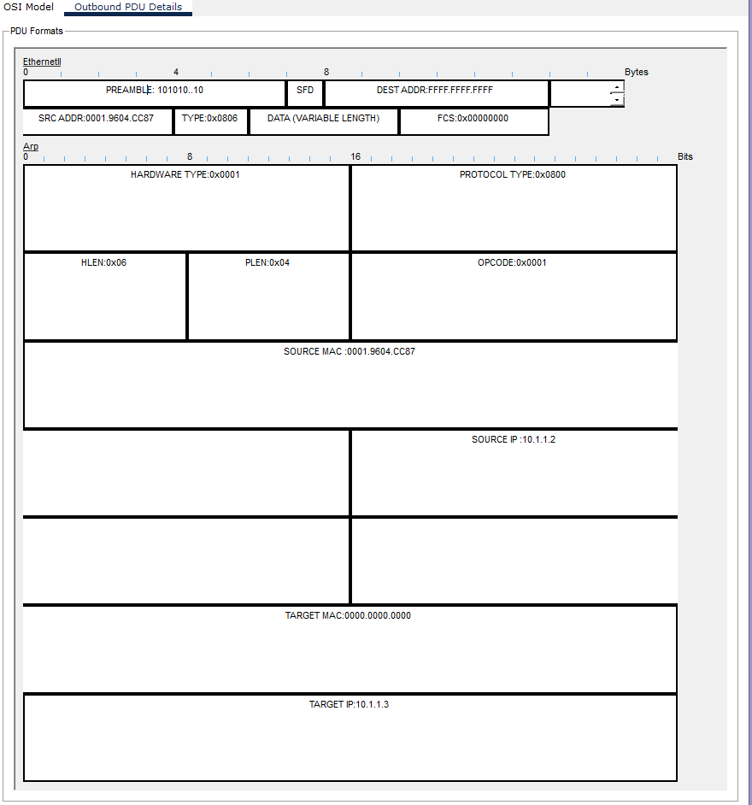

Part (ii)
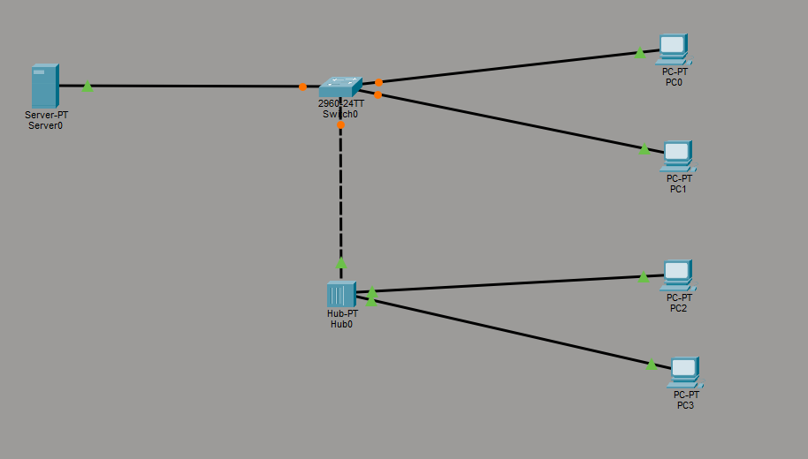
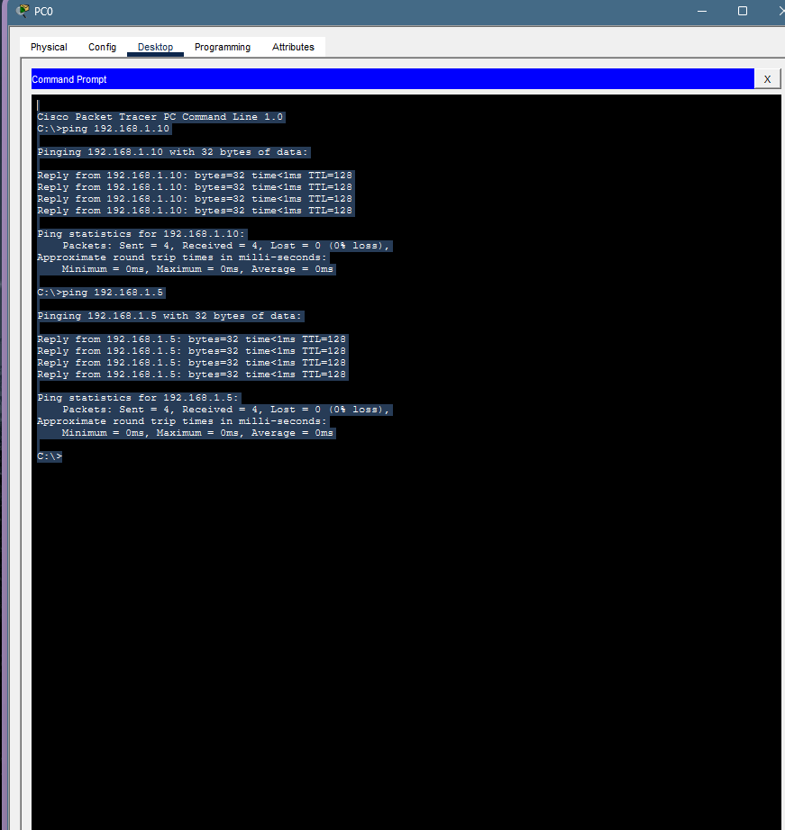
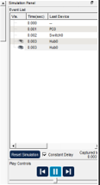
Here packet was sent from PC0 to PC3
Server acts as a centralized resource provider — PCs can send requests to this server to access data or applications.
The switch connects the server and multiple PCs (directly or via the hub).
The switch learns the MAC addresses of connected devices and sends data only to the intended destination port, reducing unnecessary network traffic.
The hub connects PC2 and PC3 to the network through the switch.
PC2 and PC3 are connected via the hub.
PC0 and PC1 are connected directly to the switch.
All PCs can communicate with each other and the server since they are part of the same LAN.

Task 2:
Here are those points rephrased:
- A hub floods incoming data to every port, sending it to all connected devices. In contrast, a switch is more intelligent; it forwards data only to the specific port of the intended destination device by reading its MAC address.
- In Cisco Packet Tracer, Physical Mode provides a visual representation of the network's real-world setup, showing the actual placement of devices in racks or rooms and how cables are physically connected. Logical Mode displays the network's logical structure, focusing on the topology, IP addressing schemes, and how devices are interconnected to communicate.
- The required cable types are:
  - Segment 1: Straight-through
  - Segment 2: Straight-through
  - Segment 3: Crossover

Task 3:
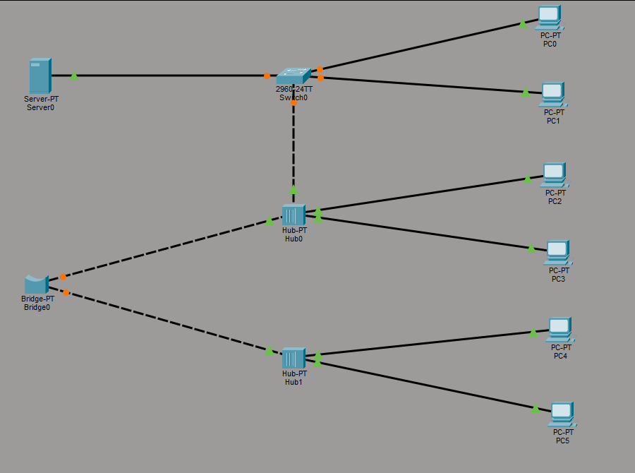
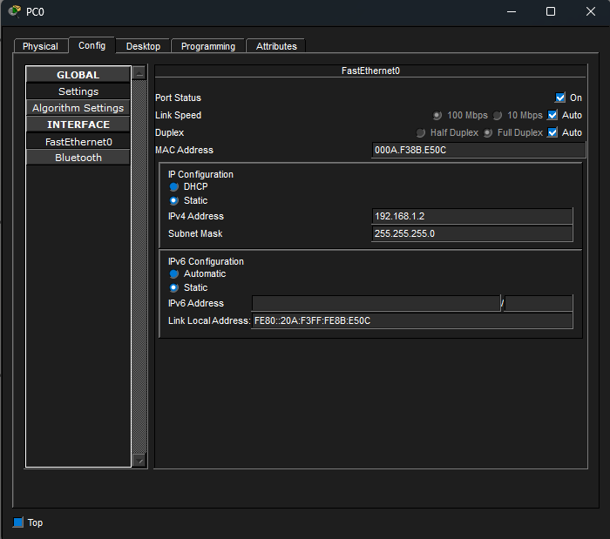
Similarly provide IP addresses to all pc (same subnet) and the server
Working of Hub: A hub is a simple Layer-1 device that does no filtering; it just takes any signal it receives on one port and repeats it out to all other ports, so every connected device receives the same data, creating one shared collision domain.

Task 4:
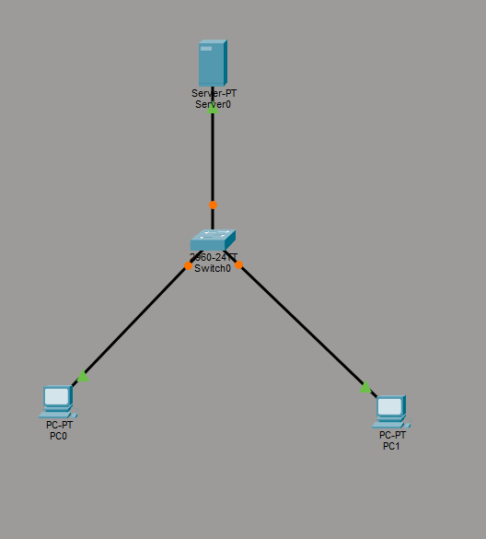

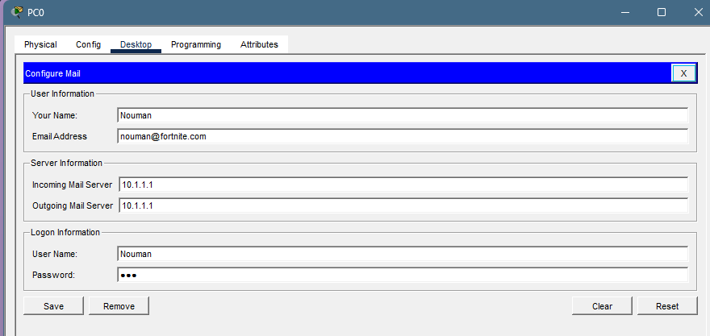

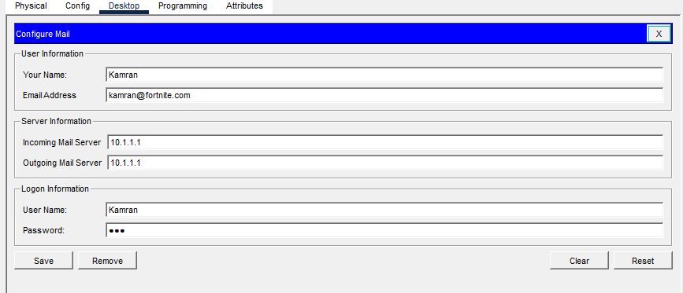

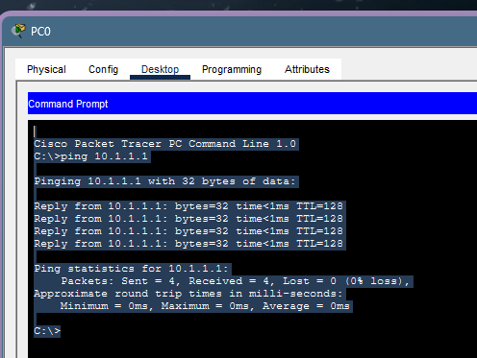
Ping: 10.1.1.1(mail server’s IP)

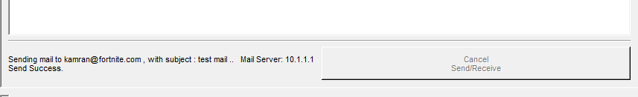

Task 5:
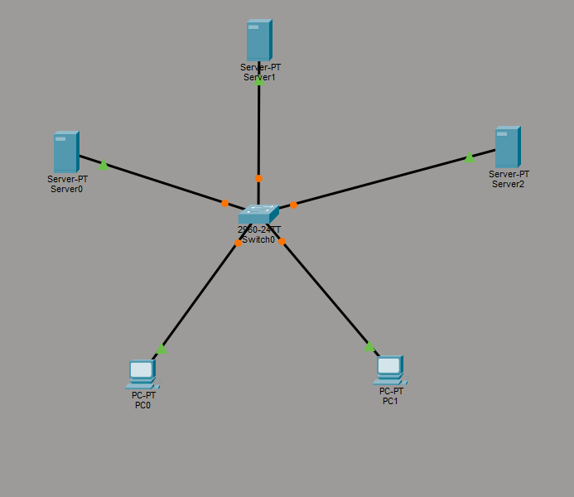
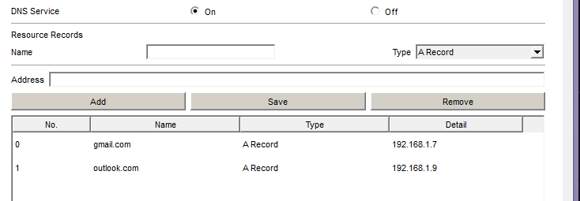
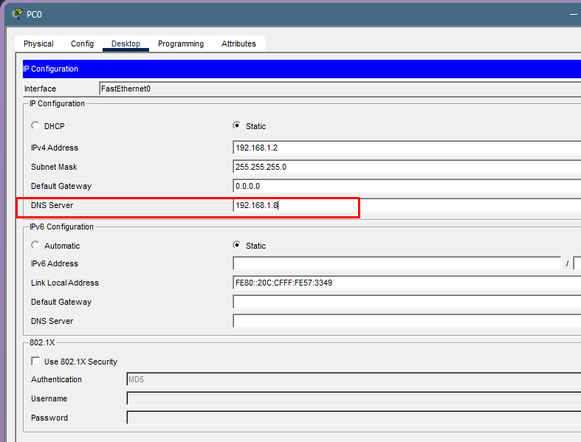
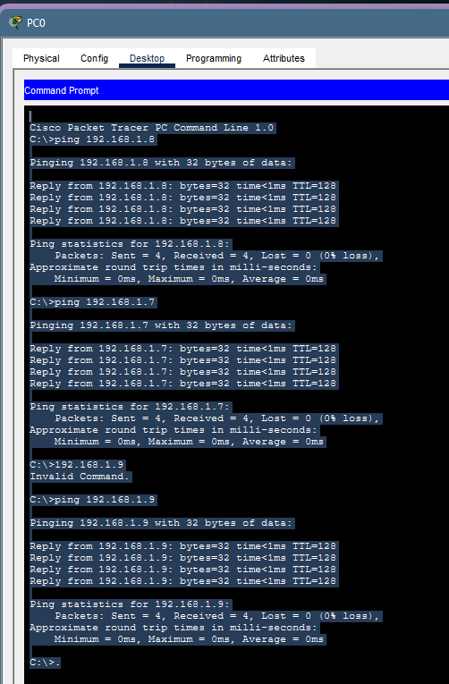
192.168.1.9: Outlook Server
192.168.1.8: DNS Server
192.168.1.7: Gmail Server
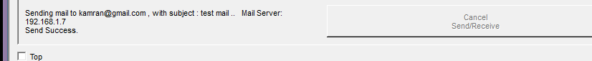

Task 6:
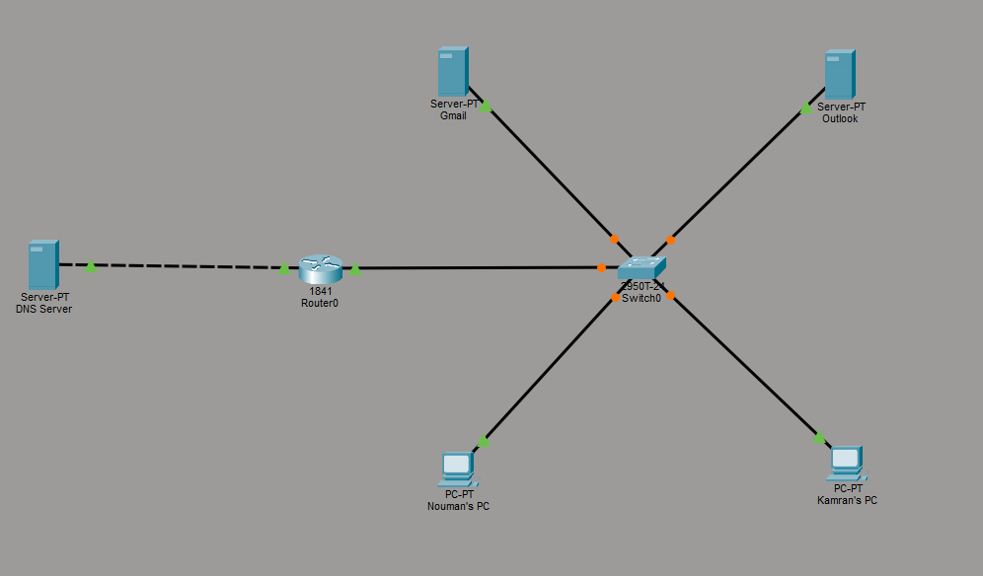
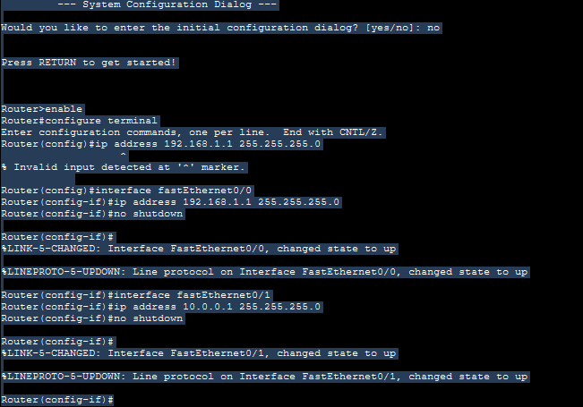
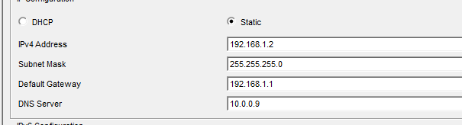
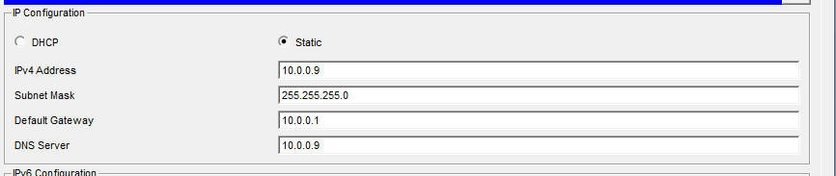
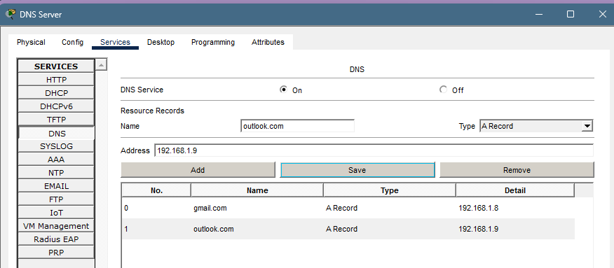
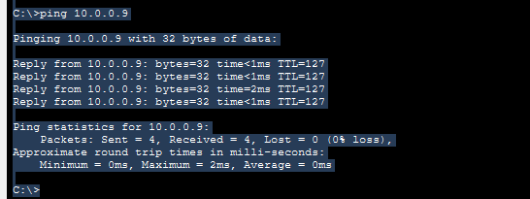

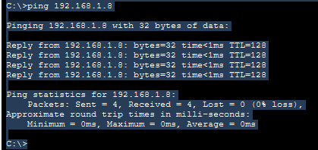

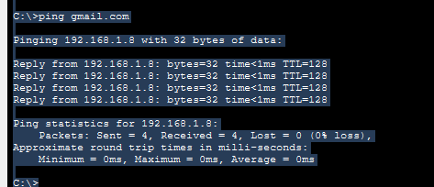

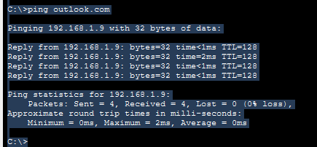

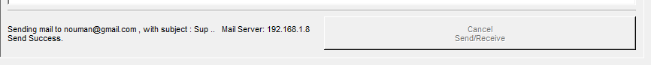

Task 7:
